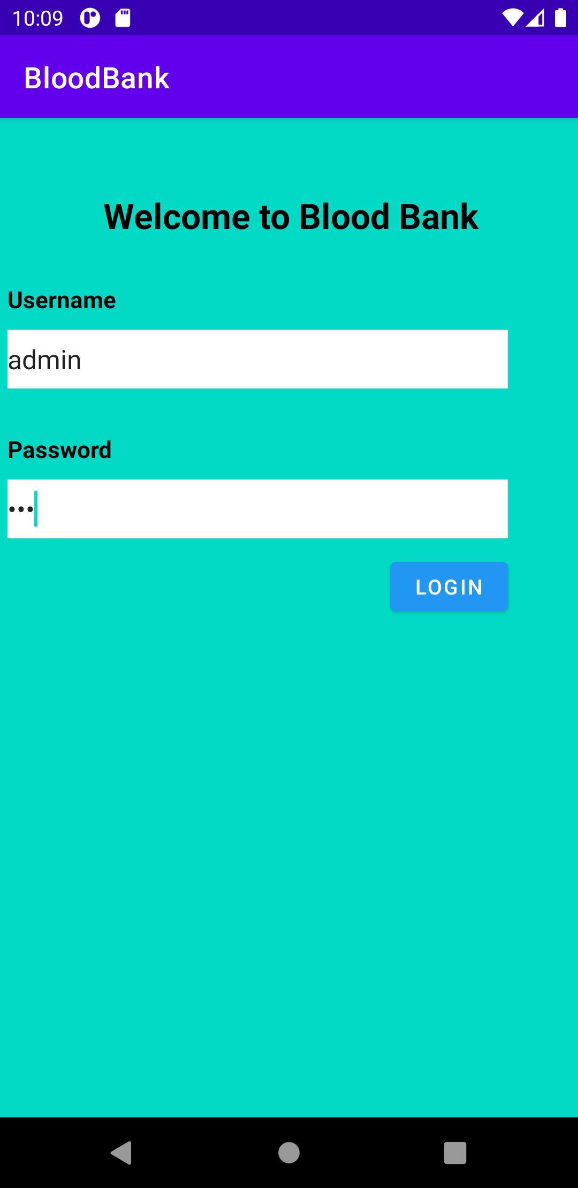

Java Code

**package** com.example.bloodbank;  
  
**import** androidx.appcompat.app.AppCompatActivity;  
  
**import** android.content.Intent;  
**import** android.os.Bundle;  
**import** android.view.View;  
**import** android.widget.Button;  
  
**public class** MainActivity **extends** AppCompatActivity  
{  
 Button **login**;  
 Button **registerr**;  
  
  
 @Override  
 **protected void** onCreate(Bundle savedInstanceState) {  
 **super**.onCreate(savedInstanceState);  
 setContentView(R.layout.***activity_main***);  
  
 **login** = findViewById(R.id.***login***);  
 **registerr** = findViewById(R.id.***registerr***);  
  
  
 **registerr**.setOnClickListener(**new** View.OnClickListener() {  
 @Override  
 **public void** onClick(View v) {  
 Intent intent = **new** Intent(MainActivity.**this**, Register.**class**);  
 startActivity(intent);  
 }  
 });  
  
 **login**.setOnClickListener(**new** View.OnClickListener() {  
 @Override  
 **public void** onClick(View v)  
 {  
 Intent intent = **new** Intent(MainActivity.**this**, Login.**class**);  
 startActivity(intent);  
 }  
 });  
 }  
 }

**XML CODE**

*<?***xml version="1.0" encoding="utf-8"***?>*<**androidx.constraintlayout.widget.ConstraintLayout xmlns:android="http://schemas.android.com/apk/res/android"  
  
 xmlns:app="http://schemas.android.com/apk/res-auto"  
 xmlns:tools="http://schemas.android.com/tools"  
 android:layout_width="match_parent"  
 android:layout_height="match_parent"  
 android:background="@color/teal_200"  
 tools:context=".MainActivity"**>  
  
 <**LinearLayout  
 android:layout_width="match_parent"  
 android:layout_height="match_parent"  
 android:orientation="vertical"**>  
 <**TextView  
 android:layout_width="wrap_content"  
 android:layout_height="wrap_content"  
 android:layout_marginLeft="70dp"  
 android:layout_marginTop="50dp"  
 android:text="Welcome to Blood Bank"  
 android:textColor="@color/black"  
 android:textSize="24dp"  
 android:textStyle="bold"**>  
 </**TextView**>  
  
 <**TextView  
 android:layout_width="wrap_content"  
 android:layout_height="wrap_content"  
 android:text="Already Registered?"  
 android:textColor="@color/black"  
 android:textStyle="bold"  
 android:layout_marginTop="30dp"  
 android:layout_marginLeft="5dp"  
 android:textSize="16dp"**>  
 </**TextView**>  
  
 <**Button  
 android:id="@+id/login"  
 android:layout_width="wrap_content"  
 android:layout_height="45dp"  
 android:layout_marginLeft="5dp"  
 android:layout_marginTop="10dp"  
 android:text="Login"  
 app:backgroundTint="#3F51B5"**></**Button**>  
  
 <**TextView  
 android:layout_width="wrap_content"  
 android:layout_height="wrap_content"  
 android:text="Visting First Time?"  
 android:textColor="@color/black"  
 android:textStyle="bold"  
 android:layout_marginTop="30dp"  
 android:layout_marginLeft="5dp"  
 android:textSize="16dp"**>  
 </**TextView**>  
  
 <**Button  
 android:id="@+id/registerr"  
 android:layout_width="wrap_content"  
 android:layout_height="50dp"  
 android:layout_marginLeft="5dp"  
 android:layout_marginTop="10dp"  
 android:text="Register"  
 app:backgroundTint="#4CAF50"**></**Button**>  
  
 </**LinearLayout**>  
  
</**androidx.constraintlayout.widget.ConstraintLayout**>



**Java Code :**

**package** com.example.bloodbank;  
  
**import** androidx.appcompat.app.AppCompatActivity;  
  
**import** android.content.Intent;  
**import** android.os.Bundle;  
**import** android.view.View;  
**import** android.widget.Button;  
  
**public class** UserLogin **extends** AppCompatActivity {  
 Button **donate**;  
 Button **need**;  
  
 @Override  
 **protected void** onCreate(Bundle savedInstanceState) {  
 **super**.onCreate(savedInstanceState);  
 setContentView(R.layout.***activity_user_login***);  
  
 **donate** = findViewById(R.id.***donate***);  
 **need** = findViewById(R.id.***need***);  
  
  
 **donate**.setOnClickListener(**new** View.OnClickListener() {  
 @Override  
 **public void** onClick(View v) {  
 Intent intent = **new** Intent(UserLogin.**this**, UserDonor.**class**);  
 startActivity(intent);  
 }  
 });  
  
 **need**.setOnClickListener(**new** View.OnClickListener() {  
 @Override  
 **public void** onClick(View v) {  
 Intent in =**new** Intent(UserLogin.**this**, UserBloodNeed.**class**);  
 startActivity(in);  
 }  
 });  
 }  
}

**XML CODE :**

*<?***xml version="1.0" encoding="utf-8"***?>*<**androidx.constraintlayout.widget.ConstraintLayout xmlns:android="http://schemas.android.com/apk/res/android"  
 xmlns:app="http://schemas.android.com/apk/res-auto"  
 xmlns:tools="http://schemas.android.com/tools"  
 android:layout_width="match_parent"  
 android:layout_height="match_parent"  
 android:background="@color/teal_200"  
 tools:context=".UserLogin"**>  
  
<**LinearLayout  
 android:layout_width="match_parent"  
 android:layout_height="match_parent"  
 android:orientation="vertical"**>  
  
 <**TextView  
 android:layout_width="wrap_content"  
 android:layout_height="wrap_content"  
 android:text="What Do You Want?"  
 android:textStyle="bold"  
 android:textSize="26dp"  
 android:layout_marginTop="70dp"  
 android:layout_marginLeft="100dp"**>  
  
 </**TextView**>  
  
 <**Button  
 android:id="@+id/donate"  
 android:layout_width="200dp"  
 android:layout_height="60dp"  
 android:layout_marginLeft="100dp"  
 android:layout_marginTop="60dp"  
 android:text="Donate Blood"  
 app:backgroundTint="#F44336"**>>  
  
 </**Button**>  
  
 <**Button  
 android:id="@+id/need"  
 android:layout_width="200dp"  
 android:layout_height="60dp"  
 android:layout_marginLeft="100dp"  
 android:layout_marginTop="20dp"  
 android:text="Need Blood"  
 app:backgroundTint="#F44336"**>>  
  
 </**Button**>  
  
</**LinearLayout**>  
  
</**androidx.constraintlayout.widget.ConstraintLayout**>

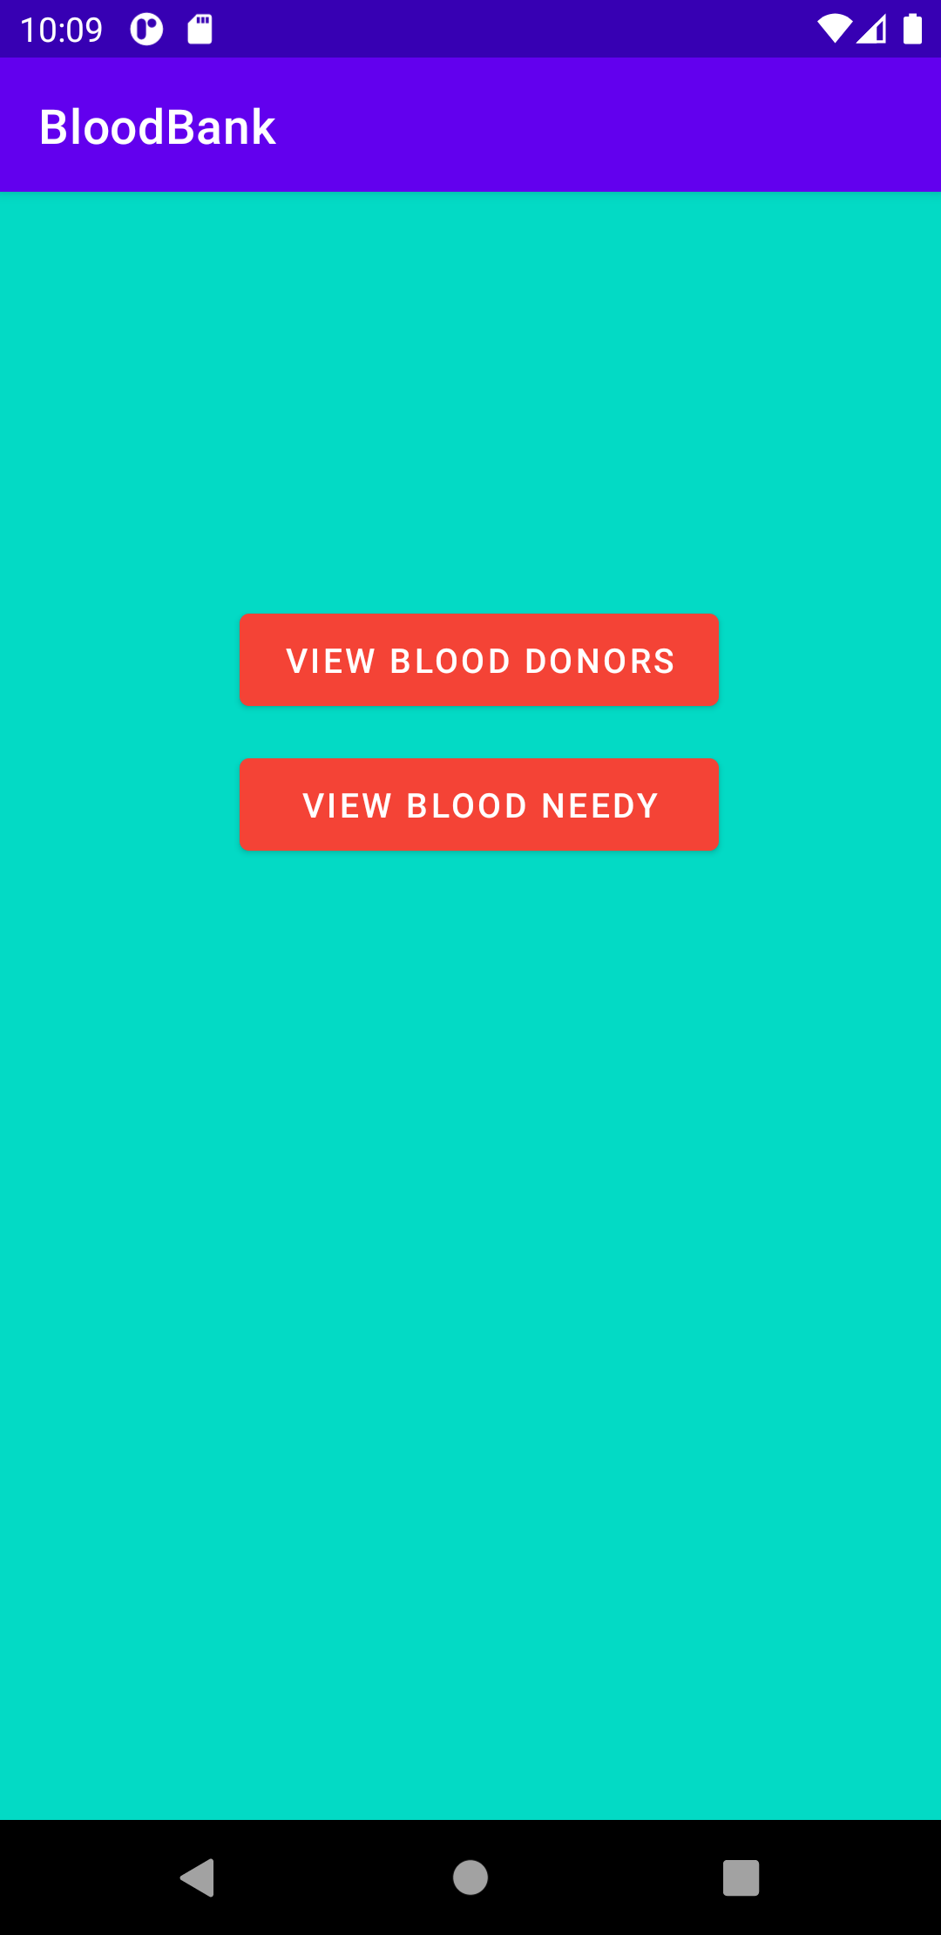

**Java Code:**

**package** com.example.bloodbank;  
  
**import** androidx.appcompat.app.AlertDialog;  
**import** androidx.appcompat.app.AppCompatActivity;  
  
**import** android.database.Cursor;  
**import** android.os.Bundle;  
**import** android.os.Message;  
**import** android.view.View;  
**import** android.view.contentcapture.DataRemovalRequest;  
**import** android.view.textclassifier.ConversationActions;  
**import** android.widget.Button;  
  
**public class** BloodBankLogin **extends** AppCompatActivity {  
 Button **btndonor**;  
 Button **btnneedy**;  
 DatabaseHelper **db**;  
  
 @Override  
 **protected void** onCreate(Bundle savedInstanceState) {  
 **super**.onCreate(savedInstanceState);  
 setContentView(R.layout.***activity_blood_bank_login***);  
  
 **btndonor** = findViewById(R.id.***viewdonors***);  
 **btnneedy** = findViewById(R.id.***viewneedy***);  
 **db** = **new** DatabaseHelper(**this**);  
  
 **btndonor**.setOnClickListener(**new** View.OnClickListener() {  
 @Override  
 **public void** onClick(View v) {  
 Cursor res = **db**.getDonor();  
 **if** (res.getCount() == 0) {  
 *//show message* showdonor(**"Error"**, **"Empty"**);  
 **return**;  
 } **else** {  
 StringBuffer buffer = **new** StringBuffer();  
 **while** (res.moveToNext()) {  
 buffer.append(**"ID :"** + res.getString(0) + **"\n"**);  
 buffer.append(**"name :"** + res.getString(1) + **"\n"**);  
 buffer.append(**"fname :"** + res.getString(2) + **"\n"**);  
 buffer.append(**"age :"** + res.getString(3) + **"\n"**);  
 buffer.append(**"address :"** + res.getString(4) + **"\n\n"**);  
  
 }  
 showdonor(**"Blood Donors"**,buffer.toString());  
 }  
 }  
 });  
  
  
 **btnneedy**.setOnClickListener(**new** View.OnClickListener() {  
 @Override  
 **public void** onClick(View v) {  
 Cursor rr = **db**.getData();  
 **if** (rr.getCount() == 0) {  
 *//show message* showneedy(**"Error"**, **"Empty"**);  
 **return**;  
 }  
 **else** {  
 StringBuffer buffer = **new** StringBuffer();  
 **while** (rr.moveToNext()) {  
 buffer.append(**"ID :"** + rr.getString(0) + **"\n"**);  
 buffer.append(**"Patient name :"** + rr.getString(1) + **"\n"**);  
 *//buffer.append("Patient Cnic :" + rr.getString(2) + "\n");  
 //buffer.append("Hospital Name :" + rr.getString(3) + "\n");  
 //buffer.append("Attendee :" + rr.getString(4) + "\n");* buffer.append(**"Gender :"** + rr.getString(5) + **"\n"**);  
 buffer.append(**"Blood Group :"** + rr.getString(6) + **"\n\n"**);  
 *//buffer.append("Gender :" + rr.getString(7) + "\n");  
 //buffer.append("Blood Group :" + rr.getString(8) + "\n");* }  
 showneedy(**"Blood Needy"**,buffer.toString());  
 }  
 }  
 });  
 }  
  
  
 **public void** showdonor(String title, String msg) {  
 AlertDialog.Builder builder = **new** AlertDialog.Builder(**this**);  
 builder.setCancelable(**true**);  
 builder.setTitle(title);  
 builder.setMessage(msg);  
 builder.show();  
 }  
  
  
 **public void** showneedy(String title, String msg) {  
 AlertDialog.Builder builder = **new** AlertDialog.Builder(**this**);  
 builder.setCancelable(**true**);  
 builder.setTitle(title);  
 builder.setMessage(msg);  
 builder.show();  
 }  
}

**XML CODE :**

*<?***xml version="1.0" encoding="utf-8"***?>*<**androidx.constraintlayout.widget.ConstraintLayout xmlns:android="http://schemas.android.com/apk/res/android"  
 xmlns:app="http://schemas.android.com/apk/res-auto"  
 xmlns:tools="http://schemas.android.com/tools"  
 android:layout_width="match_parent"  
 android:layout_height="match_parent"  
 android:background="@color/teal_200"  
 tools:context=".BloodBankLogin"**>  
  
 <**LinearLayout  
 android:layout_width="match_parent"  
 android:layout_height="match_parent"  
 android:orientation="vertical"**>  
  
 <**Button  
 android:id="@+id/viewdonors"  
 android:layout_width="200dp"  
 android:layout_height="50dp"  
 android:layout_marginLeft="100dp"  
 android:layout_marginTop="170dp"  
 android:text="View Blood Donors"  
 app:backgroundTint="#F44336"**>  
  
 </**Button**>  
  
 <**Button  
 android:id="@+id/viewneedy"  
 android:layout_width="200dp"  
 android:layout_height="50dp"  
 android:layout_marginLeft="100dp"  
 android:layout_marginTop="10dp"  
 android:text="View Blood Needy"  
 app:backgroundTint="#F44336"**>  
  
 </**Button**>  
  
 </**LinearLayout**>  
  
</**androidx.constraintlayout.widget.ConstraintLayout**>

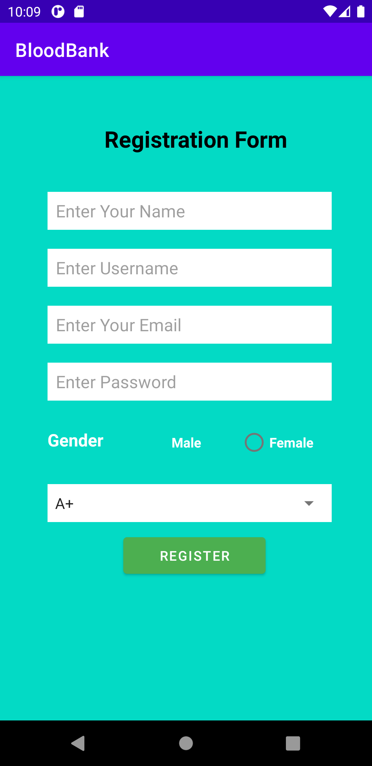

**Java Code**

**package** com.example.bloodbank;  
  
**import** androidx.appcompat.app.AppCompatActivity;  
  
**import** android.app.AlertDialog;  
**import** android.database.Cursor;  
**import** android.os.Bundle;  
**import** android.text.TextUtils;  
**import** android.view.View;  
**import** android.widget.AdapterView;  
**import** android.widget.ArrayAdapter;  
**import** android.widget.Button;  
**import** android.widget.EditText;  
**import** android.widget.RadioButton;  
**import** android.widget.RadioGroup;  
**import** android.widget.Spinner;  
**import** android.widget.TextView;  
**import** android.widget.Toast;  
  
**public class** Register **extends** AppCompatActivity **implements** AdapterView.OnItemSelectedListener {  
 String[] **bgroup** = {**"A+"**, **"A-"**, **"AB+"**, **"AB-"**, **"O+"**, **"O-"**};  
 String **id**;  
 String **gender**;  
 EditText **name**;  
 EditText **username**;  
 EditText **password**;  
 EditText **email**;  
 Spinner **spbgroup**;  
 RadioGroup **rdbg**;  
 RadioButton **male**;  
 RadioButton **female**;  
 Button **register**;  
 DatabaseHelper **db**;  
  
 @Override  
 **protected void** onCreate(Bundle savedInstanceState) {  
 **super**.onCreate(savedInstanceState);  
 setContentView(R.layout.***activity_register***);  
  
 **name** = findViewById(R.id.***name***);  
 **username** = findViewById(R.id.***username***);  
 **email** = findViewById(R.id.***email***);  
 **password** = findViewById(R.id.***password***);  
 **db** = **new** DatabaseHelper(**this**);  
 **register** = findViewById(R.id.register);  
 rdbg = findViewById(R.id.rgbg);  
 male = findViewById(R.id.male);  
 male.setChecked(**true**);  
 female = findViewById(R.id.female);  
 AddData();  
  
 rdbg.setOnCheckedChangeListener(**new** RadioGroup.OnCheckedChangeListener() {  
 @Override  
 **public void** onCheckedChanged(RadioGroup group, **int** checkedId) {  
 **if** (checkedId == R.id.male)  
 {  
 gender=male.getText().toString();  
  
 }  
 **else if**(checkedId == R.id.female)  
 {  
 gender=female.getText().toString();  
 }  
 }  
 });  
  
  
 spbgroup = findViewById(R.id.bgroup);  
 ArrayAdapter<String> adbg = **new** ArrayAdapter<String>(**this**, android.R.layout.simple_spinner_item, bgroup);  
 adbg.setDropDownViewResource(android.R.layout.simple_spinner_dropdown_item);  
 spbgroup.setAdapter(adbg);  
 spbgroup.setOnItemSelectedListener(**this**);  
 }  
  
 **public void** AddData() {  
 register.setOnClickListener(**new** View.OnClickListener() {  
 @Override  
 **public void** onClick(View v) {  
 **if** (TextUtils.isEmpty(name.getText().toString())) {  
 name.setError(**"Please fill this field"**);  
 } **else if** (TextUtils.isEmpty(username.getText().toString())) {  
 username.setError(**"Please fill this field"**);  
 } **else if** (TextUtils.isEmpty(password.getText().toString())) {  
 password.setError(**"Please fill this field"**);  
 } **else if** (TextUtils.isEmpty(email.getText().toString())) {  
 email.setError(**"Please fill this field"**);  
 } **else** {  
 **boolean** inserted = db.insertdata(name.getText().toString(), username.getText().toString(), email.getText().toString(), password.getText().toString(), gender, spbgroup.getSelectedItem().toString());  
 **if** (inserted = **true**) {  
 Toast.makeText(Register.**this**, **"Data Inserted"**, Toast.LENGTH_LONG).show();  
 } **else** {  
 Toast.makeText(Register.**this**, **"Data Not Inserted"**, Toast.LENGTH_LONG).show();  
 }  
 }  
  
 }  
 });  
 }  
 @Override  
 **public void** onItemSelected(AdapterView<?> parent, View view, **int** position, **long** id) {  
  
 }  
  
 @Override  
 **public void** onNothingSelected(AdapterView<?> parent) {  
  
 }  
}

**XML Code :**

*<?***xml version="1.0" encoding="utf-8"***?>*<**androidx.constraintlayout.widget.ConstraintLayout xmlns:android="http://schemas.android.com/apk/res/android"  
 xmlns:app="http://schemas.android.com/apk/res-auto"  
 xmlns:tools="http://schemas.android.com/tools"  
 android:layout_width="match_parent"  
 android:layout_height="match_parent"  
 android:background="@color/teal_200"  
 tools:context=".Register"**>  
  
 <**LinearLayout  
 android:layout_width="match_parent"  
 android:layout_height="match_parent"  
 android:orientation="vertical"**>  
  
 <**TextView  
 android:layout_width="wrap_content"  
 android:layout_height="wrap_content"  
 android:layout_marginLeft="110dp"  
 android:layout_marginTop="50dp"  
 android:text="Registration Form"  
 android:textColor="@color/black"  
 android:textSize="24dp"  
 android:textStyle="bold"**>  
  
 </**TextView**>  
  
 <**EditText  
 android:id="@+id/name"  
 android:layout_width="300dp"  
 android:layout_height="40dp"  
 android:layout_marginTop="40dp"  
 android:layout_marginLeft="50dp"  
 android:background="@color/white"  
 android:hint=" Enter Your Name"**>  
  
 </**EditText**>  
  
 <**EditText  
 android:id="@+id/username"  
 android:layout_width="300dp"  
 android:layout_height="40dp"  
 android:layout_marginTop="20dp"  
 android:layout_marginLeft="50dp"  
 android:background="@color/white"  
 android:hint=" Enter Username"**>  
  
 </**EditText**>  
  
 <**EditText  
 android:id="@+id/email"  
 android:layout_width="300dp"  
 android:layout_height="40dp"  
 android:layout_marginTop="20dp"  
 android:layout_marginLeft="50dp"  
 android:background="@color/white"  
 android:hint=" Enter Your Email"**>  
  
 </**EditText**>  
  
 <**EditText  
 android:id="@+id/password"  
 android:inputType="textPassword"  
 android:layout_width="300dp"  
 android:layout_height="40dp"  
 android:layout_marginTop="20dp"  
 android:layout_marginLeft="50dp"  
 android:background="@color/white"  
 android:hint=" Enter Password"**>  
  
 </**EditText**>  
  
 <**LinearLayout  
 android:layout_width="wrap_content"  
 android:layout_height="wrap_content"  
 android:layout_marginTop="20dp"  
 android:orientation="horizontal"**>  
  
  
 <**TextView  
 android:layout_width="match_parent"  
 android:layout_height="match_parent"  
 android:text="Gender"  
 android:layout_marginLeft="50dp"  
 android:textStyle="bold"  
 android:layout_marginTop="9dp"  
 android:textSize="18dp"  
 android:textColor="@color/white"**>  
  
 </**TextView**>  
  
 <**RadioGroup  
 android:id="@+id/rgbg"  
 android:layout_width="wrap_content"  
 android:layout_height="wrap_content"  
 android:orientation="horizontal"**>  
  
 <**RadioButton  
 android:id="@+id/male"  
 android:layout_width="match_parent"  
 android:layout_height="match_parent"  
 android:layout_marginLeft="40dp"  
 android:selectAllOnFocus="false"  
 android:text="Male"  
 android:textColor="@color/white"  
 android:textStyle="bold"**>  
  
 </**RadioButton**>  
  
 <**RadioButton  
 android:id="@+id/female"  
 android:layout_width="match_parent"  
 android:layout_height="match_parent"  
 android:text="Female"  
 android:textStyle="bold"  
 android:layout_marginLeft="40dp"  
 android:textColor="@color/white"**>  
  
 </**RadioButton**>  
 </**RadioGroup**>  
 </**LinearLayout**>  
  
 <**LinearLayout  
 android:layout_width="300dp"  
 android:layout_height="40dp"  
 android:layout_marginTop="20dp"  
 android:layout_marginLeft="50dp"  
 android:background="@color/white"  
 android:orientation="vertical"**>  
  
 <**Spinner  
 android:id="@+id/bgroup"  
 android:layout_width="match_parent"  
 android:layout_height="match_parent"**>  
  
 </**Spinner**>  
 </**LinearLayout**>  
  
 <**Button  
 android:id="@+id/register"  
 android:layout_width="150dp"  
 android:layout_height="50dp"  
 android:layout_marginLeft="130dp"  
 android:layout_marginTop="10dp"  
 android:text="Register"  
 app:backgroundTint="#4CAF50"**></**Button**>  
  
 </**LinearLayout**>  
  
</**androidx.constraintlayout.widget.ConstraintLayout**>

**DataBase**

**package** com.example.bloodbank;  
  
**import** androidx.appcompat.app.AlertDialog;  
**import** androidx.appcompat.app.AppCompatActivity;  
  
**import** android.database.Cursor;  
**import** android.os.Bundle;  
**import** android.os.Message;  
**import** android.view.View;  
**import** android.view.contentcapture.DataRemovalRequest;  
**import** android.view.textclassifier.ConversationActions;  
**import** android.widget.Button;  
  
**public class** BloodBankLogin **extends** AppCompatActivity {  
 Button **btndonor**;  
 Button **btnneedy**;  
 DatabaseHelper **db**;  
  
 @Override  
 **protected void** onCreate(Bundle savedInstanceState) {  
 **super**.onCreate(savedInstanceState);  
 setContentView(R.layout.***activity_blood_bank_login***);  
  
 **btndonor** = findViewById(R.id.***viewdonors***);  
 **btnneedy** = findViewById(R.id.***viewneedy***);  
 **db** = **new** DatabaseHelper(**this**);  
  
 **btndonor**.setOnClickListener(**new** View.OnClickListener() {  
 @Override  
 **public void** onClick(View v) {  
 Cursor res = **db**.getDonor();  
 **if** (res.getCount() == 0) {  
 *//show message* showdonor(**"Error"**, **"Empty"**);  
 **return**;  
 } **else** {  
 StringBuffer buffer = **new** StringBuffer();  
 **while** (res.moveToNext()) {  
 buffer.append(**"ID :"** + res.getString(0) + **"\n"**);  
 buffer.append(**"name :"** + res.getString(1) + **"\n"**);  
 buffer.append(**"fname :"** + res.getString(2) + **"\n"**);  
 buffer.append(**"age :"** + res.getString(3) + **"\n"**);  
 buffer.append(**"address :"** + res.getString(4) + **"\n\n"**);  
  
 }  
 showdonor(**"Blood Donors"**,buffer.toString());  
 }  
 }  
 });  
  
  
 **btnneedy**.setOnClickListener(**new** View.OnClickListener() {  
 @Override  
 **public void** onClick(View v) {  
 Cursor rr = **db**.getData();  
 **if** (rr.getCount() == 0) {  
 *//show message* showneedy(**"Error"**, **"Empty"**);  
 **return**;  
 }  
 **else** {  
 StringBuffer buffer = **new** StringBuffer();  
 **while** (rr.moveToNext()) {  
 buffer.append(**"ID :"** + rr.getString(0) + **"\n"**);  
 buffer.append(**"Patient name :"** + rr.getString(1) + **"\n"**);  
 *//buffer.append("Patient Cnic :" + rr.getString(2) + "\n");  
 //buffer.append("Hospital Name :" + rr.getString(3) + "\n");  
 //buffer.append("Attendee :" + rr.getString(4) + "\n");* buffer.append(**"Gender :"** + rr.getString(5) + **"\n"**);  
 buffer.append(**"Blood Group :"** + rr.getString(6) + **"\n\n"**);  
 *//buffer.append("Gender :" + rr.getString(7) + "\n");  
 //buffer.append("Blood Group :" + rr.getString(8) + "\n");* }  
 showneedy(**"Blood Needy"**,buffer.toString());  
 }  
 }  
 });  
 }  
  
  
 **public void** showdonor(String title, String msg) {  
 AlertDialog.Builder builder = **new** AlertDialog.Builder(**this**);  
 builder.setCancelable(**true**);  
 builder.setTitle(title);  
 builder.setMessage(msg);  
 builder.show();  
 }  
  
  
 **public void** showneedy(String title, String msg) {  
 AlertDialog.Builder builder = **new** AlertDialog.Builder(**this**);  
 builder.setCancelable(**true**);  
 builder.setTitle(title);  
 builder.setMessage(msg);  
 builder.show();  
 }  
}

